**《Steel Pittsburgh》Rulebook:**

**Welcome to "Steel Pittsburgh"! In this game, you will play as a member of the capitalist faction, the environmentalist faction, or the politician faction, competing for resources, deploying strategies, and interacting with other players to achieve victory. In the city of Pittsburgh, where industry and nature coexist, every decision you make will impact the future of the city.**

**Game Objective:**

**Your goal is to obtain the most victory points through resource management and strategic decision-making. Capitalists aim to expand their industrial empires, Environmentalists strive to protect natural resources.**

**Game Components:**

**Game Board: Displays the map of Pittsburgh and resource areas.**

**Character Cards (8): Environmentalists (4), Capitalists (4).**

**Currency/Dollar (hundreds): 5, 10, 20, 50.**

**Based on the current amount of money each player has, divide it into different stages and provide a different amount of interest for each stage:**

**Stage 1: 0-50 money, fixed interest of 5 money.**

**Stage 2: 51-100 money, fixed interest of 10 money.**

**Stage 3: 101-200 money, fixed interest of 15 money.**

**Stage 4: 201 money and above, fixed interest of 20 money.**

**Vote (per 10 people): 5, 10, 20, 50.**

**Conquest Cards (Capitalists Fraction: costs 50 money, 20 Vote) (Environmentalist Fraction: costs 50 Vote, 20 money). = 18**

**War Card (costs 70 Vote) *6**

**Assassination Card (costs 70 money) *6**

**Impeachment Card (costs 70 Vote). *6**

**Object Card: Prevent a Player’s any action immediately. *9**

**Resource/Environment tokens.**

**Initial Setup: At the game start, each player will receive a amount of dollar * 100 and Vote* 80**

**Environmentalists Roles:**

**The Environmentalist (Famous Pittsburgh Environmentalist)**

**Rachel Louise Carson**

Skill 1, Mass Support: You double the Vote gained from occupying a territory.

Skill 2, No Time to Waste: Limited skill. Immediately remove all resource tokens from the target territory and restore one ecological environment destroyed by a Conquest card on the game board.

Senator Requirement: Occupy 10 territories.

Senator Skill: Only when this character is a Senator, the environmental faction does not lose Vote.

**The Ecologist (World's Leading Environmental Scientist)**

**Alexander von Humboldt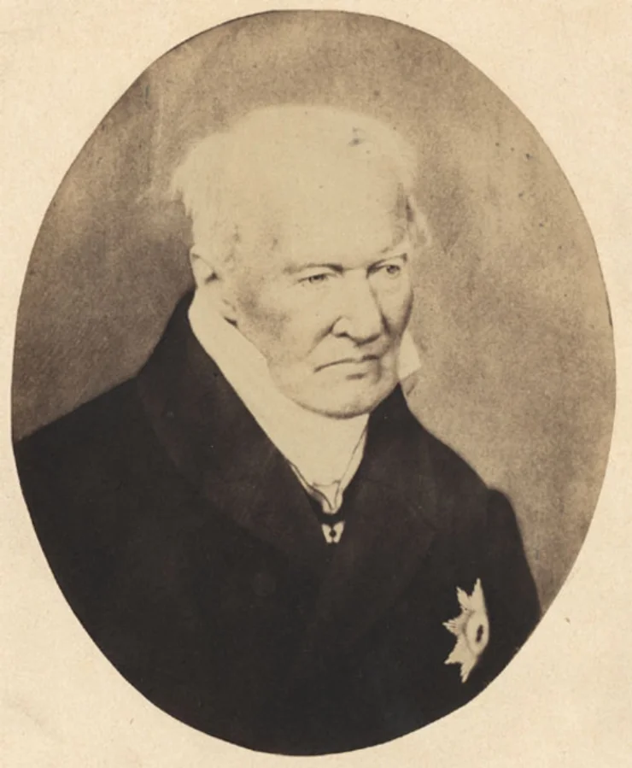**：

Possessing unique knowledge and skills, you can accelerate resource regeneration and natural environment restoration.

Skill 1, Erudition: Once per round: Remove one resource token from the target territory; if the selected territory has no resource tokens, instead let a teammate gain one environmental token.

Skill 2, Environmental Thesis: Limited skill. You and all your teammates to reduce the upper limit of environment tokens required for all tiles by 1 for one round.

Senator Requirement: Occupy a total of 3 territories using environmental tokens.

Senator Skill: Choose a territory without resource tokens as the target; it cannot be developed for the next X rounds (X determined by you). Also, until X rounds have passed, you cannot activate the skill again.

**The Green Activist**

**William S. Dietrich**：

Skill 1, Wars: Automatically trigger a War once the combined Vote of the team reaches 50/100/150 and 200 respectively. This allows for organizing demonstrations and protests in the city, restricting the actions of capitalists.

Skill 2, Charity Fundraising: Once per play phase, skip your own play phase. You and all your teammates additionally gain 40 money.

Senator Requirement: Trigger four Wars or four fundraisers, counted separately.

Senator Skill: You don't need Vote to trigger Wars, and you don't need to skip your play phase to trigger fundraisers. Additionally, you can actively use each of these effects once per round.

**Citizen Representative**

Represents the interests of city residents, able to mobilize voters and social organizations, influencing the direction of city politics.

Once per round: You can convert one Conquest card into an Impeachment card. Passive: Your Conquest Cards can be played as War cards, and your War cards can be played as Conquest Cards.

Senator Requirement: A total of 8 converted cards have been played in the lineup.

Senator Skill: Once per round: Gain one Conquest card, one Impeachment card, and one War card.

**Capitalist Roles：**

**Industrial Tycoon**

**Andrew Carnegie** With abundant resources and capital, you can rapidly expand your industrial empire in a short period.

There is no limit to the use of Conquest cards.

For every two Conquest cards played, it counts as an additional use of an Conquest card.

Senator Requirement: A total of 6 Conquest cards have been used by the team.

Senator Skill: Only when this character is a Senator, the cost of Conquest cards is reduced to 25 money and does not require Vote.

**Resource Developer**

**William Richard Jones**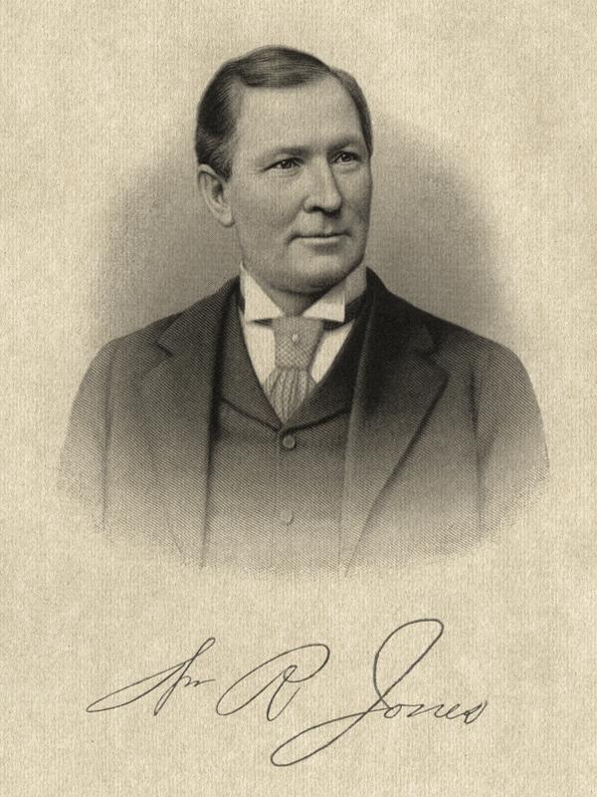

Skill 1: Extraction: Place an additional resource token on each territory with a resource token.

Skill 2: Salvage (Passive): Whenever a resource token is removed, gain 50 money.

Senator Requirement: The total amount of money for the team reaches 500.

Senator Skill: Only when this character is a Senator, the earnings from the "Salvage" skill are doubled.

**Financier**

**Henry Clay Frick** Proficient in financial investment and fund management, able to effectively manipulate the market and gain additional profits.

Skill 1: Investment: At the beginning of the play phase, you can invest all your money in a specific territory. When this territory is successfully developed by your team, you receive 120% of the invested money.

Skill 2: Management: Once per round, at the beginning of the round, immediately skip this turn and gain money.

Senator Requirment: Gained 600$

Senator Skill: Double the Interest in your campaign in every stage.

**Industrial politician**

**James Blackmore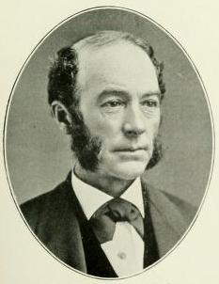**：

Industrial politician

Skill 1: You can convert one Conquest card into an assassination card.

Skill 2: Once per match: When a character uses an impeachment card, you can forcibly change its target.

Senator Requirement: Assassinate or impeach two different characters from opposing factions, counted collectively.

Senator Skill: Lose 100 Vote, or lose 20 Vote and discard an assassination card, to prevent the implementation of a bill.

**Territories:**

Both environmentalists and capitalists can complete their respective game objectives by placing tokens on territories. Each territory can have a maximum of three tokens. For capitalists, they must first mark a territory using a Conquest card and then use money to obtain resource tokens, placing any number of tokens on the developed territory. The number of resource tokens requirements represents the development level of the territory, with higher development level territories bringing in higher money returns. For environmentalists, using an Conquest card can prevent a target territory from being developed. If effective, environmentalists can place the Conquest card on a territory for one round, indicating that the territory cannot be developed temporarily.

**Squirrel Hill** - Residential Area, Natural Area, Education District

**Oakland** - Educational District

**Shadyside** - Financial District, Residential Area

**East Liberty** - Industrial Area, Resource Area

**Bloomfield** - Residential Area, Financial District

**Homestead** - Industrial Area

**Point Breeze** - Natural Area, Residential Area

**South Side** - Industrial Area, Resource Area

**Downtown** - Industrial Area, Financial District

**Beechview Brookline** - Resource Area

**Mount Washington** – Natural Area

**Lawrenceville** - Residential Area, Educational District

**Highland Park** - Natural Area

Different combinations of territories will produce different additional effects, bringing certain rewards to players:

**Residential Area + Natural Area:** Doubling the Vote *2 of your faction immediately.

**Financial District + Residential Area**: By constructing a financial district, a large number of residents are attracted, increasing the amount of money and Vote gained in the next 3 rounds by +20.

**Industrial District + Financial District:** The industrial district and financial district have formed a close alliance, with everyone in the faction using Conquest cards +1.

**Resource Area + Green Area:** A large number of resources is discovered in the green area. All members of the faction immediately receive +5 resource tokens, but Vote is halved.

**Natural Area + Education Area:** Recognizing the importance of caring for nature through education, everyone in the faction gains +1 use of environmental tokens.

**Industrial District + Residential Area:** Successfully building a new factory in the residential area doubles everyone's money. Immediately launch a War on one previous field that owned by this campaign.

**Senator:**

Each faction can have only one Senator at a time. When a Senator meets their special individual requirement could appear in each faction, they can use the seven following exclusive cards:

Pittsburgh Real Estate: To some extent, reduce the money needed to purchase real estate. Lasts for 4 rounds.

Pittsburgh Immigration Act: Attract a large number of immigrants to Pittsburgh, who crave stable jobs. All territories receive reduced resource /environmental token -1.

City Greening Plan: This bill aims to increase the city's green space and improve its environmental quality. The campaign of the Senator will first provide a fund (150$) to green industrial areas, then they will receive compensation for future (5 round) Vote loss (-50 loss amount). It also requires 2 Conquest cards to respond to each Conquest card for the next 2 rounds.

Urban Poverty Mutual Aid Foundation: This bill establishes an urban sustainable development fund to support poor families and unemployed people in the city. The faction of the Senator who introduces this bill needs to contribute 20$ to the foundation per round, gaining 25% extra after obtaining Votes for 2 rounds.

Urban Cultural Heritage Protection Act: This bill aims to protect the city's historical and cultural heritage, including historical buildings, relics, and traditional culture. The faction of the Senator consumes 100 moneys to maintain historical and cultural heritage in educational territories, doubling *2 Votes in that faction.

Urban Innovation Technology Development Plan: This bill aims to promote the city's technological innovation and development, supporting innovative enterprises and the development of the technology industry. It can grant a technology enterprise, and each member of the Senator's faction immediately receives an Conquest Card.

Game Phases:

Preparation Phases:

Place the game board on the game table center to ensure all players can easily see it.

Place game components such as resource cards, Conquest, environmental bill cards, law implementation cards, assassination tokens, impeachment tokens, American democracy tokens, War Cards, bribery tokens, resource point cards, etc., in their designated areas.

Each player randomly draws a character card from the character card deck to determine their identity, then groups them according to their identity into the environmentalist faction, capitalist faction, and Senator faction.

Each faction selects player representatives according to the specified number to ensure each faction has appropriate representation.

The player starting the game is determined based on the last digit of the game start time. If there are more players than the total number, the player in the position of the remainder after dividing by the total number of players starts the action. The first player starts the game from the Homestead territory.

Game Start:

The game is divided into multiple rounds, each consisting of the following phases: resource acquisition phase, action phase, event phase, scoring phase. Each round proceeds clockwise, with an undeveloped map block designated as the contested resource for that round. After the round ends, the map block is marked as developed by the respective faction.

Resource Acquisition Phase: Each player obtains resource cards from the resource card deck according to their character card's special abilities and the game situation. Natural growth: money ++/Votes ++.

Action Phase: Players take turns to perform actions, choosing to develop resources on the game board, restore ecological environments, launch demonstrations and protests, or interfere with other players using special cards in hand.

Event Phase: Execute corresponding event content based on the description on the event card, which may include natural disasters, political events, etc.

Scoring Phase: Calculate the score for each faction based on the resource development situation, ecological environment restoration, and law enactment situation on the current game board. Update the score on the resource point card.

Game End:

The game end condition can be reaching a preset number of rounds or when a certain faction reaches a certain number of victory points.

The game starts from the designated map block, and when the game rounds pass through the last map block, the game ends.

After the game ends, determine the winner based on the score of each faction and proceed with summary and awards.

**TL; DR version**

1. Game Objective:

- Players aim to accumulate the most victory points through resource management and strategic decision-making.

- The objectives vary slightly between factions: Capitalists focus on expanding their industrial empire, environmentalists strive to protect natural resources, and politicians seek to monopolize power over the city's fate.

2. Game Components:

- Board: Displays a map of Pittsburgh and its resource areas.

- Character Cards: Different cards for environmentalists, capitalists, and politicians.

- Plots: Used for resource development and environmental restoration.

- Special Items: Such as resource markers, Conquest Card, environmental act cards, etc.

3. Game Setup:

- Set up the board and game components.

- Randomly draw character cards to determine identities, dividing players into factions of environmentalists, capitalists, and politicians.

- Each faction selects representative characters.

4. Game Start:

- The game consists of multiple rounds, each including phases for resource acquisition, action, events, and scoring.

- Each round starts from different map sections to ensure fairness.

5. Resource Acquisition Phase:

- Each player obtains resources from the resource card deck according to their character's abilities and the game situation.

6. Action Phase:

- Players take turns performing actions such as resource development, ecological restoration, and protest demonstrations.

- Use special cards to interfere with other players.

7. Event Phase

- Execute events as described on the event cards, which may include natural disasters, political events, etc.

8. Scoring Phase:

- Calculate each faction's score based on resource development, ecological restoration, and the passage of laws.

- Update the scores on the resource point cards.

9. Game End:

- The game ends either after a predetermined number of rounds or when a faction reaches a set number of victory points.

- At game end, determine the winner based on the scores, and conclude with a summary and awards ceremony.